Ride With Nancy
Sunday, April 23, 2006

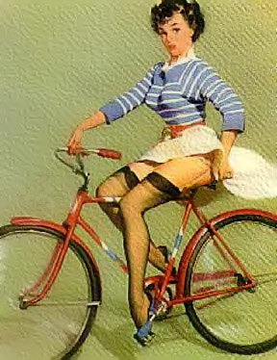
Nine hardy riders and 1 escort met at Timmies in Fall
River - we had a few newbies this year
- Pack it in Pack it Out and lovely Linda, who spent her time in the car studying the habits and failings of senior citizens (go figure the bank has told her to get this course)
- Randy and Kevin "I live in Moncton now", who
we have met more often in canoes than on bikes
- Monica "I've got to get to church to play the organ"
- Judy, sporting a lovely new blue biking jacket
- Betty and Chris
- Nancy & Gord.

Viking is now aka "Life Saver" as his colour combinations of bright red, yellow, green, remind Judy of roll of life saver candy.
It was a great morning - sunny and clear. Off we set down the Waverley Road to the Parklow, along a path by the now empty lot where the Dartmouth Y once stood, under the highway and on to the trail through Shubie Park and the Lake Charles Trail, which brought us out on the Waverley Road again and back to Fall River and breakfast at Bill's Diner.

No flats. It was a wonderful ride and all enjoyed the jewel of a park in our own backyard.
Next week - meet at the Esquire Restaurant on the Bedford Highway for a ride around the Basin. Breakfast at the Esquire. See you on Sunday at 8:30 am!

(Peggy's Cove ride delayed for a week due to car complications in the Hollebone household)

Jerome.
=======================================================

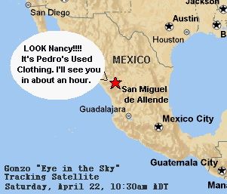
Meanwhile, our Gonzo "Eye in the Sky" Tracking Satellite, as always, is keeping close surveillance on ALL Gonzo members and has come up with this:

