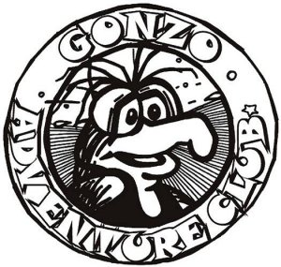

Gonzo AGM,
Planning Session
and Feeding Frenzy
Saturday, March 6, 2004

The wise man who once again shrugged off our annual Gonzo AGM and Planning Session, refusing to attend because we “always do the saaaaame things every year”, was proven wide of the mark. To demonstrate our flexibility, this time around we delayed the meeting, typically held in November, until March, thereby proving him grossly erroneous.

With the wind whipping over five foot snow banks on the outside, we were warm and toasty inside our official winter quarters on Newton Avenue, albeit in the skuzzier part of Halifax, one mile west of the elite Lawrence Street section. Relocation to our summer quarters on Fall River’s Lake Thomas will take place once the damn snow disappears.

In Attendance
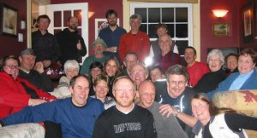
Quorum was ascertained with the attendance of Mark Stein (our host), Sue Fowler, Chris & Betty Hollebone, Barb Hall, Greg Vail, Gordie, Nancy & Jeff Warnica, Bruce & Nancy Duffy, Wayne & Linda Banks, Perry & Gilda Abriel, Greg & Ann MacDonald, Jerome & Gail Bruhm, Bruce Murphy, Ross Mitchell, Ron Jeppesen, Dawn Gillingham, Dave Jellicoe and John McCracken.

Belly Up
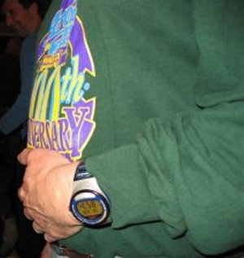
Naturally, the first order of business was to eat (and why not?). Delicacies consisted of cabbage rolls, pineapple meat balls, baked beans, chili, Smelt Brook Chicken, scallops wrapped in bacon, chicken livers wrapped in bacon, pizza, salads and ONE solitary dessert, an apple pie freshly baked by Ron Jeppesen………….I mean by Sobey’s. Whatever has happened to us? We used to have lots of desserts in the old days. Nevertheless, it was all good.

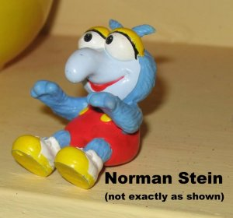
Election of Officers

As for the business meeting, Norman Stein was, once again, nominated for the position of President. Being absent, from the meeting for the 5th year in a row, and thereby unable to defend himself, he was voted in (unanimously, I might add) for the 5th year in a row. The position of Treasurer will be the person most in need of a boost to their personal cash flow at any given point during the year. The position of Secretary will, once again, remain vacant due to the lack of writing and comprehension skills within the group.

The Planning Session
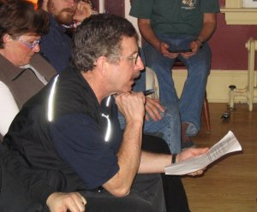
Mr. Duffy chaired the planning portion of the meeting while others upheld the age-old Gonzo tradition of butting in, cutting off and carrying on unrelated boisterous conversations among themselves. Even Duffy’s superior vocal amplitude failed to fracture the din. No one knows for sure what events were planned or recorded as a result of the disjointed mayhem that prevailed. We’ll have to trust Duffy’s good memory and check our Gonzo Web Site for details.

Dipper-de-do-Dah
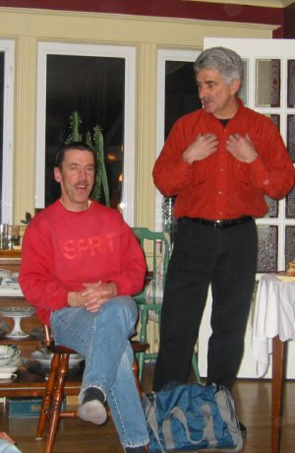
Young Murphy (Dipper) has given a lot to the Gonzos over the years, most notably through his fine work in producing and managing our web site. This year it was his turn to be patted on the back (OK, criticized less) by his fellow Gonzo members as a show of our thanks for all he does for us.

While Mr. Duffy opened the tribute with glowing comments about Murphy, I felt compelled to point out that he has a rotten streak in him as well, evidenced by his nasty little notes placed here and there throughout the year…..most notably in a gift book presented to me at last years Rum Runners Relay where his note of encouragement read, “I never liked you”………and another occasion where his comment, to me, stated “You pig”.

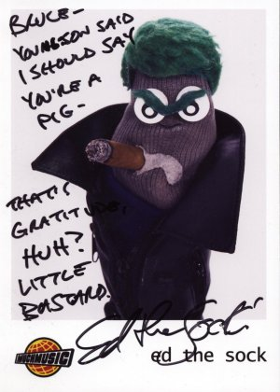

My turn for revenge…….or so I thought. Rather than stooping to the low of calling my good buddy a “pig”, I solicited the assistance of a higher power, one of Murphy’s idols, to do it for me. Ed the Sock agreed to take on the task.

But as it turned out, even Ed thinks that Bruce is a cool dude. The little scum bag (I mean sock) double-crossed me with an insult aimed at my son, Jon, who collected the autographed photo of Ed while he worked with him at Much Music last fall.

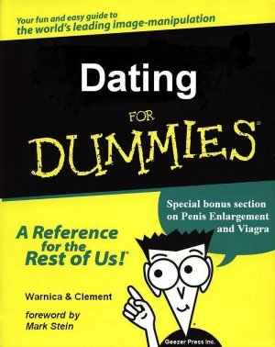
Oh well, on to Phase II of the presentations.

Murphy is “out there” these days, “on the prowl”, “looking for the babes”. The problem is that, the last time Murphy was “out there” was back in the 1970s. “Things” aren’t the same as they used to be back then (if you know what I mean).

We went to great labours to have a guidebook produced for our man “on the prowl”. Sparing no expense, we secured the services of the two foremost experts on today’s topic of “What Women Want” - Warnica & Clement - to author the book for us, with a foreword by, who else, Mark Stein.

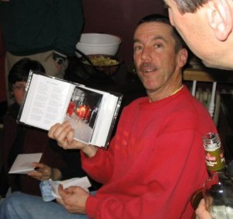

Actually, the book contained memories of Dipper’s Gonzo Family Moments - a selection of photos of Murphy hiking, biking, running, drinking beer with Martha ……………and wearing his favourite red dress in public.

Phase III - Ode To Dipper

Next up was Nancy Warnica, our Gonzo Poet, with one of her fine offerings in honour of Murphy.

What can we say
About our Dipper -
He's smart, he's wise,
And even a stripper!
Every puddle of water
Calls out to him -
"Lounge in me baby
Let me caress your skin!"
When it comes to computers
Then Dipper's the man.
He updates and programs
What we demand.
Our website is awesome
A surfers delight.
He works on it diligently,
To get it just right.
And a camper - a pro.
He's efficient and neat.
Never moving - just sitting,
With all at his feet.

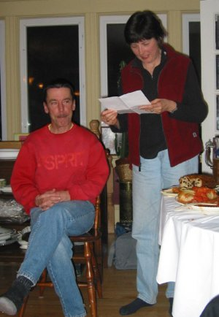
Just see the man paddle,
With speed and finesse.
He's up to the challenge.
He's one of the best.
And a cyclist too -
He toots up and down
The hills of the city,
The hills of small towns.
He's tough on those hills.
Always up to the task.
He heeds Vikings call-
"Don't ever be last!"
Me thinks that's it -
'Bout this mutitalented man – Oops
- to mention his running -
Oh it's kinda’ canned!
But never say never!
He's sure to come back.
It's speed work and hills
You know - all that crap!

So here's to your future -
And goodbye to Dal!
When retirement comes.
And you're outta’ hell!
Thanks Dipper!
Nancy Warnica
March 2004

And then, the gift (Phase IV)
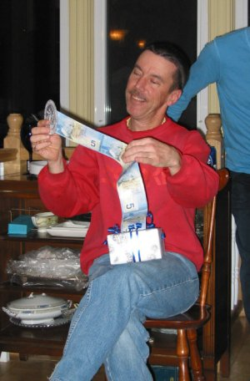
Murphy likes “gear”. We could have purchased something for him, but why risk it. We opted to give him cash instead, and let him decide what piece of gear he will purchase at …….TAO (recommended), MEC, The Trail Shop……… or the Hollis Street Stroll.

But, how do you wrap cash in an interesting way? I gave it my best shot – thirty crisp new, and real, $5.00 bills taped, end to end, to be unraveled (by Dipper) from a gift box wrapped in Gonzo paper. Unfortunately, the production was obscured as the horde in attendance continued to clutter the air space with superfluous commentary as I attempted to orchestrate the presentation.

Bottom Line

Murphy liked the cash!

Meanwhile……

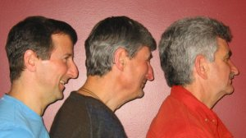

………in another section of the room, the competition was heating up. As per the photo on the left, who in the Gonzo Family is the most well endowed? You be the judge.



And, in the other corner, a bit of a spat broke out, centered around another physical comparison by two of our members (as per the photo on the right)……..you know, which of the two lady’s in question has the cutest husband.

Comment of the Evening

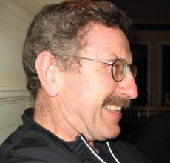
Many smart things were said and done as the evening wore on and the customary 9:00 curfew approached. All things considered, the Comment of the Evening title has to go to Mr. Duffy who, in the middle of one of his verbose contributions, stumbled over his words for a brief second, declaring (out loud), “My mouth is getting tired”.

You heard it here first.

Conclusion

I can’t imagine a better way, or a more interesting group of friends, to guide me into my twilight, then golden years.

Somewhat respectfully submitted,
jcb

A message from our sponsor

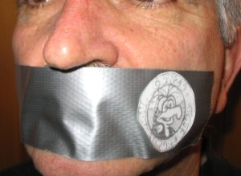
This write-up was brought to you by the makers of Gonzo Silencing Tape ™. When you are attempting to offer a presentation to an unruly mob, who’s members insist on interjecting unsolicited verbal flotsam, causing the ordeal to become about as futile as trying to herd cats (a Jeppesenism), reach for a roll of Gonzo Silencing Tape. Properly applied to offending members of the group (as illustrated) it will afford you the benefit of carrying out your presentation quickly and effectively. For severe cases, we recommend our Gonzo Silencing 12 Gauge Shot Gun™ (ask for details).

