Miles To Go Before We Sleep
Hiking in the White Mountains, August 14 – 18, 2003
by Jerome Bruhm

The Frost Place

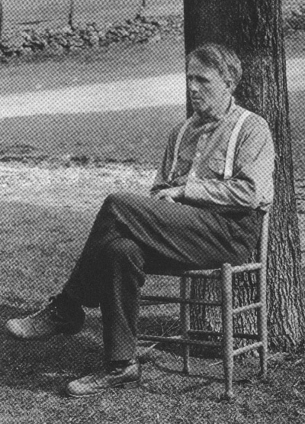
If my memory serves me correctly, this was my 5th visit to Gonzo’s official White Mountain hiking retreat, the Pinestead Farm Lodge (The Farm), in Fraconia, New Hampshire. Each trip has been special in it’s own way.

While there on previous occasions, I had often noticed a sign pointing to “The Frost Place” just up the road from The Farm. I hadn’t yet explored the side road beyond that sign. This time I found a few spare hours to satisfy my curiosity.

The Frost Place was home to Robert Frost and his family from 1915 until 1920. Frost, of course, is one of the most loved American poets of all time. Joseph Brodsky, winner of the Nobel Prize for Literature in 1987, wrote of Frost: “He is generally regarded as the poet of the countryside, of rural settings – as a folksy, crusty, wisecracking gentleman farmer, generally of positive disposition.” ………..sounds to me like someone who would, surely, have enjoyed joining the Gonzos on the front veranda of The Farm to chuckle the evening away after a long day’s hike.
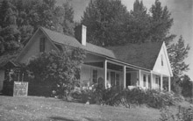
It was a wonderful few hours at The Frost Place, strolling through the half-mile trail behind the house; reading the poetry that’s posted on various trees and meditating while sitting on Robert Frost’s front porch, enjoying the view of the countryside that inspired many of his works.

I am not a poet, nor can I read poems properly. And, in general, I don’t “get” poems. But, as stated in The Frost Place brochure: It is well for us to remember Frost’s dictum that a poem should inspire its own interpretation. With that in mind, Mr. Frost will assist me with the remainder of this manuscript.

I have climbed the hills of view
And looked at the world, and descended;
I have come by the highway home,
And lo, it is ended.
- Robert Frost

Come on, come on, come on! Let’s go, let’s go, let’s go!

As usual, our trip started in HRM at 4:00am on a dark morning as sleepy zombies grumbled their way to various vehicles, with programmed stops at the Stewiacke Tim’s for coffee; the Sussex McDonald’s for breakfast; Miller’s for lunch and a mid-afternoon arrival at The Farm. If you really had to pee along the way – well, that’s too bad. Unscheduled stops are prohibited. For some reason, we have to set a new PB each time we head out. Bragging rights go to those who can get there the fastest.

Wait a minute – that’s not how it happened this time. Some of us dared to be different. In our case, my good buddy, Wayne Banks, stopped by my house not at 4:00am, but at 6:00am. We loaded the car and drove casually into the daylight. OK, we did visit the Stewiacke Tim’s, but the other standard stops fell by the wayside as we established a new PW time of 13 hours for the trip, and arrived relaxed, and still in plenty of time to enjoy several hours of socializing on The Farm’s veranda before dozing off for the night. I totally recommend this divergence from the normal travel path. Heck, I even got to stop for a pee this time.

Two roads diverged in the wood, and I –
I took the one less traveled by,
And that has made all the difference.
– Robert Frost

In the Beginning

Bodies assembled on the veranda, and the gigglefest gained momentum as we awaited the arrival of our Guests of Honour. Gordie Warnica and Ross Mitchell, now in the last legs (no pun intended) of their Thru-hike on the Appalachian Trail would be by soon. We were there to visit them and to, hopefully, provide them with a boost as they headed into the remaining 300 miles of their 2100 mile journey.

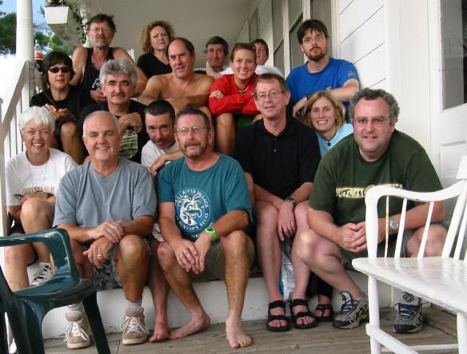
Some of the crew members had arrived on Thursday; others arrived at various times on Friday. Barb Hall, and friends, were busy whipping up a huge pot of Barb’s famous spaghetti sauce for the evening meal. The rest of us chatted, noisily, among ourselves while Bruce Murphy was off hiking with Gordie and Ross. Bruce Duffy, Nancy and Jeff Warnica, Barb Hall, Greg Vail, Kirsten Mitchell and Shelly Sheehan had hiked Wildcat that afternoon. Linda Mitchell was NOT HERE TO HIKE!!!! (so she informed us). Robert Kaufman and Sue Sipos arrived from Montreal. Perry and Gilda Abriel, who were camping near Gorham, dropped by for a visit.

They arrived.

Out of the mud two strangers came.

– Robert Frost

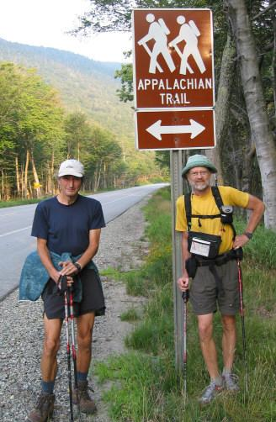
Five months of hiking can do wonders in helping to reduce one’s gut size……….leg size, arm size, neck size, etc. We first noticed this when half of Ross emerged from the car in the parking lot upon his arrival. The rest of Ross lies scattered somewhere along the trail from New Hampshire to Georgia. We were amazed at how slim and “trail worthy” Ross had become. Linda, in her irreverent humour, saw it differently - sternly offering, “He looks sick!”

Gordie had also shed pounds but, amazingly, he looked somewhat more dapper than Ross. He was in less need of a hair cut; beard neatly trimmed and he walked (OK, “shuffled”) somewhat erect. Who would have thought we’d see the day when Gordie would come out on top in a Best Groomed competition with Mr. Dress Up (Ross)?

Let me say that I have never considered hiking the complete Appalachian Trail. That is not something I’d want to do. But that’s me. It’s been Gordie’s long-time dream and Ross came on board a few years ago. I have nothing but admiration for their commitment and tenacity, especially after having seen them in action this past week-end. They are, truly, to be admired by all.
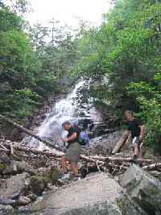
But I have promises to keep,
And miles to go before I sleep,
And miles to go before I sleep.
- Robert Frost

The Saturday Hike
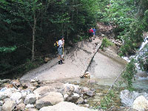
We were up and on our way Saturday morning at 7:00am. We dropped Gordie, Ross, Kirsten and Shelly at the Mt. Liberty trailhead. Robert and Sue made plans to meet Ross and Gordie at the Gale River entrance. The rest of use chose the Falling Waters Trail and would meet the Liberty crew at the top - “the rest of us”, of course, means all but Linda, who was NOT HERE TO HIKE!!!! (remember?).

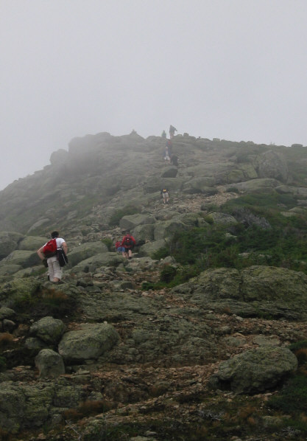
The nice weather at the bottom turned into wind, fog and water droplets at the top as we crossed to Lincoln and Lafayette. As for the gorgeous scenery – better go another time for that. But it was fun nonetheless, and the fog did add it’s own special flavour.

Gordie and Ross continued on to Gale River. The rest of us came back to our cars via Greenleaf Hut and the Old Bridle Path. There weren’t a lot of volunteers among us who felt they could keep up to the amazingly quick pace being set by Ross and Gordie.
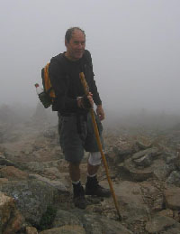

Wayne’s knee injury was acting up so he decided to take it easy on the way down. To my good fortune, I opted to stay with him. What a difference when you take a break from competitive hiking, so to speak, and stop to smell the roses along the way. Although our time (3 hours) was over an hour behind the leaders, we maintained “book time”. Some say that “book time” was established by an elderly, decrepit person, walking with either two crutches or a walker. Not so. More realistically, “book time” is the speed at which one can expect to hike a particular trail while enjoying nature to the fullest.

These pools that, though in forest, still reflect
The total sky almost without defect.
- Robert Frost

Saturday Evening Meal

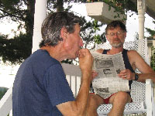
All were back at The Farm in good time. Tonight’s meal would be Hearty Soup, made from a base prepared by yours truly. Not having a big budget to work with, Wayne and I collected roadkill on the trip from home, adding various bits of meat, internal organs and the odd clump of fur to the base, which turned it into a rather tasty offering. To assist our sham, Robert and Sue claimed that they brought the meat from home. Rabbit raisins made a good substitute for what the rest mistook for chic peas. It worked, and people seem to like it. Although, I think Barb caught on as she offered to supplement the soup with sloppy joes created from the previous evening’s spaghetti sauce. And, I noticed that she didn’t eat any of my soup.

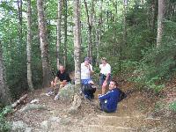
Sunday Hikes

Sunday morning Gordie and Ross were off to hike another section of the trail. The rest of us (except Linda….you know the story) hiked up to the Lonesome Lake Hut where the group split, with one band hiking up to “Sungod Pond” to explore the origins of Duffy’s trail name. The other band headed back down to the parking lot and onward to The Farm. It was a great day for a hike – sunny and warm. Lonesome Lake was gorgeous.

The Gonzo License Plate

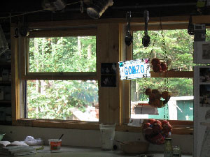

Several years ago Gordie left his “Gonzo” vanity license plate at Mizpah Hut as a contribution to the hut worker’s collection of trail souvenirs. We had heard that, as hut workers will do, the Gonzo plate had been the booty of a raid or two and that it had, at one time, been at Lonesome Lake Hut. It had, however, since been traded with another hut in return for an autographed photo of Rob Lowe.

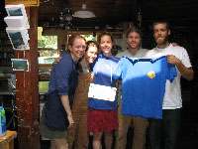
To our amazement, the Gonzo plate did, in fact, return to Lonesome Lake Hut a few days before our arrival. It was hanging in the kitchen window with a rope attached so that various hut workers could wear it around their neck as they served meals to the hikers. They were simply ecstatic to meet a group of “Gonzos” and to learn the origins of the plate. We took a photo of them with the Gonzo plate and they took a photo of us with the Gonzo plate.

To their further amazement (and to the sound of kazoo music and the clapping of hands) Nancy peeled off the Gonzo PPP T-shirt she was wearing that morning, and gave it to the hut workers as a companion for the Gonzo plate (a bit of editorial license used here). They do have the shirt – that’s all you need to know.

Sunday Afternoon and Supper

Sunday afternoon various people did various things. Some continued hiking; some slept; some went to North Conway for a bit of shopping and I made my way to the aforementioned Frost Place. Perry & Gilda arrive for another visit later in the day.

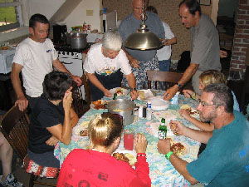
Sunday evening’s meal featured Linda’s famous Super Bowl Chili, and it was very good! To show my gratefulness I offered my thanks to Linda, telling her the chili was “very good”………….Big mistake!

“Just ‘very good’???? Is that all???????”, she barked in response, eyes bulging with her best make believe angry look. It seems that, in the Mitchell household, one must get up and tap dance around the table to demonstrate the acceptable level of appreciation for any of Linda’s culinary creations. The utterance of anything akin to “very good” doesn’t quite seem to cut it.

In total, the food was “tap dance worthy” during the entire extended week-end (I missed the Thursday evening barbecued steak, but I hear that it was quite up to par.). We were amazed at how we were able to feed so many with what seemed to be a relatively small quantity. (And he commanded the multitude to sit down on the grass, and took the five loaves, and the two fishes, and looking up to heaven, he blessed, and brake, and gave the loaves to his disciples, and the disciples to the multitude…………..do you suppose?)

The Veranda Monologues

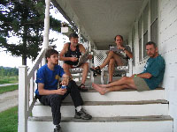
The hiking was fantastic, but so were the yakking sessions that took place on the veranda each evening. I will pass on a few highlights.

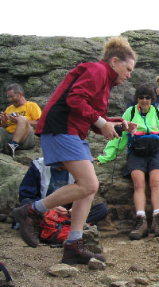
Have you ever heard Barb tell a joke? It reminds me of the old days of watching the Red Skelton Show. Red would laugh more at his own jokes than anyone else, which, of course, made them even funnier. Well, that’s Barb.

She told one of the dumbest jokes I have ever heard about a disease called Hong Kong Dong. It would have surely gone flat had anyone other than Barb (or Red Skelton, of course) told it. But she did the voices; she did the gestures and she giggled her way through the entire joke. The result was a total uproar as she delivered the punch line.

Then she went on to tell us about her dog. Unfortunately, he had a hind leg amputated, which of course is no joke. But he’s learned to cope well, even the part where he has to cock his only hind leg to pee. Barb’s demonstration of him doing a modified handstand got the crowd roaring again.
Linda chimed in on a related topic, which I shall not explain other than to quote her subject line, “1-2-1-2-1”. (A definite winner - you had to be there.)

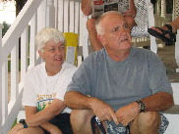
On the topic of pain relief, Perry offered a cure for headaches – the kind that puts the sufferer into a bad mood. He said that whenever Gilda comes down with one, he finds that crushed aspirin works well, “I just put an aspirin between her eyes and hit it with a hammer”.

And it continued on downhill from there.

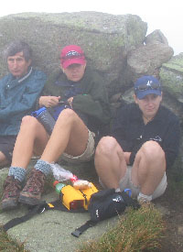
Trail Names

It has come to our attention that there are members without proper trail names and a couple with names that need a revision. First up are Kirsten and Shelly – both without trail names.

Bruce Duffy suggested “Legs” as a suitable label for Kirsten. It seems that both he and Bruce Murphy had trouble keeping up with Kirsten during the hikes, and blamed it on the fact that she has longer legs than them. (Do you suppose Kirsten’s relative hiking speed could have anything to do with the fact that the combination of the Burces two ages adds up to a three digit number while Kirsten is still hovering in the vicinity of the quarter century mark?)

The suggested name for the vertically challenged Shelly was “No Legs”.

Another suggestion was a team name for the two of them - “Lewis & Clarke” (in honour of two great explorers), based on Kirsten’s and Shelly’s propensity for wandering off the trail, as demonstrated on a few occasions.

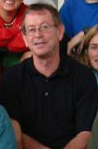
And what about Greg Vail? His trail name, “Fireball”, is based on a single occasion when he nearly burned down a cabin at Kejimkujik with his camp stove. Time for a new handle – one that’s not based on a one-off incident.

Should Greg possibly be targeted for his long-standing practice of leaving his watch at “Halifax time” while visiting other time zones? Seems to me he had Barb up at 3:00am on Saturday morning because he used the wrong calculation in converting Halifax time to local time, in his head, when setting his watch alarm the previous evening …..……and Monday morning he had her up at 4:30am rather than 5:30am because, for some reason, he figured we all meant we wanted to leave at 6:00am Halifax time rather than 6:00am local time???????

A suggestion for a new trail name for Greg was “Local Time”. I’d like to throw in “Sir Sanford” as a possibility, in honour of Sir Sanford Fleming who caused all of the grief for Greg by establishing Global Time Zones to make it easier for the other 16 of us on the trip. Hopefully, like Sir Sanford, Greg, too, will some day discover Global Time Zones.

Since we’re talking trail names, I’m up for review as well. My name “Geezer” is limp. It’s based on my e-mail address. Come on people – you can do better than that.

The Road Home

We headed out toward home on Monday morning. Some went to Gorham for breakfast at McDonalds; some went to Skowhegan for the New Balance Factory sales; some went shopping elsewhere. We said our Good Byes as Gordie and Ross were delivered to yet another trailhead. Only 26 days to go.

As always, we had a lot of fun and it is a true blessing that we have each other - to love and to tantalize. Overall, I have to say this one goes down as one of my all-time favourite week-end hiking sessions. Thank you, everyone.

I’ll leave the final words to Robert Frost. Let’s all treasure our memories for they are special.


Nature’s first green is gold,
Her hardest hue to hold.
Her early leaf’s a flower;
But only so an hour.
Then leaf subsides to leaf.
So Eden sank in grief,
So dawn goes down to day.
Nothing gold can stay.
- Robert Frost

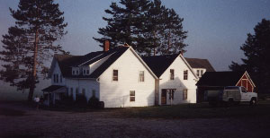

“The Farm”

