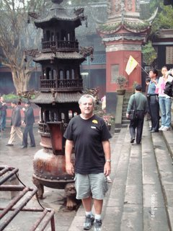
Weekends are for exploring this area of central China……Nov. 12 and 13 we headed to Chengdu, Robert’s second time as he had gone to this area a month ago with his teaching colleague, John and wife Kris. Then, the three of them explored 2 areas near Chengdu: Mt Quingchengshan and the Dujiangyan Irrigation System. This irrigation system is the oldest operating one in the world. 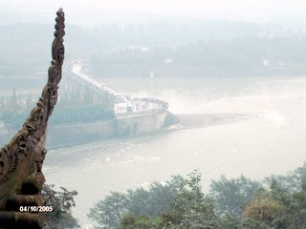
This time we checked out the multitude of offerings within the city of Chengdu. First, we took a 4 hour bus ride from the Yangiapo Bus terminal, the inter-city bus station. Smooth, efficient, with a pit-stop half-way……civilized and enjoyable, in SHARP contrast to our return via another route.
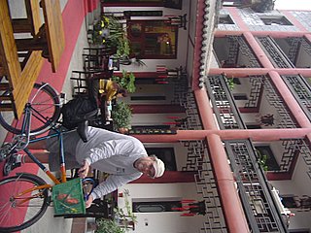
For Sue, it was a joy to see the countryside: lush green vegetation, with meticulously terraced farm areas and low-lying rice paddies. Surprisingly there were no animals in evidence, which accounts for the much lower protein and fat consumption in the Chinese diet. Another oddity is there is little fresh milk as we know it, rather boxed and ultra-pasteurized milk….as well, very little cheese which was a shock to my cheese-loving system. You can see how the Chinese have much lower cholesterol rates and maybe lower incidence of heart disease as well as much smaller physiques. Statistics on this are hard to come by as this is not a very transparent society and there is little evidence of systems of accountability!
Anyways, on to Chengdu! Robert had surfed-out a great accommodation there, a former monastery-now- B & B, called the Wenjun Mansion Hotel…..wonderful spot with an open courtyard from our 3rd floor which double as the breakfast area. Bathroom was nicer than our apartment’s! www.dreams-travel.com/wenjun.
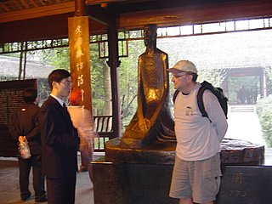
First day in Chengdu we walked/biked over to the Dufu Thatched Cottage, nestled in a huge garden park full of flowers, goldfish ponds, walkway and eating areas. Dufu was a poet from the 3rd century (see statue as Robert talks to our interpreter Frank), who was rebelling against the norms of the day and had a series of imprisonments and then was ultimately honored for his great contributions to Chinese culture. Chairman Mao was instrumental in setting this Cottage up and in one of the pavilions one can see many pictures of visiting dignitaries from around the world: Charic, Schroeder, and, emotionally for us, a picture of Trudeau and one of his sons who had visited in 1980.
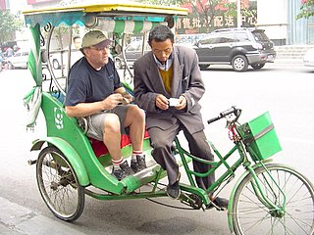
In the afternoon, we took a series of rickshaw rides throughout this modern city, much cleaner and less hectic than Chongqing, more green and people spaces.
We stopped for lunch and had THE best meal ever (we keep saying this with every meal!) …..Sechwan style but “Bu-La” which we have learned to say, meaning NOT SPICY!!! Robert is getting very adept at ordering and it was a tasty, colorful, yummy meal, with great and attentive service. The accompanying beer was good too, for the Gregs of this world to know!!!!
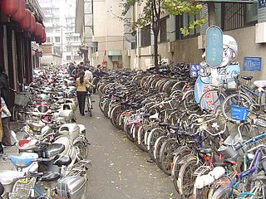
We continued on this very flat landscape, compared to the hills and twisty-turnings of Chongqing with hundreds of bicycles, motorized bicycles, motorized and non-motorized rickshaws.
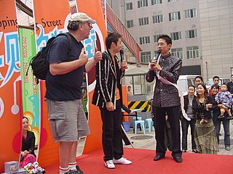
At one point we shopped in an upscale area, with Robert getting up on stage with the buskers and dancing down the runway as he sang “Hava Nagilla” into the microphone! Again Robert’s adventurous spirit in evidence especially as he THEN sat down with a group of card-players and proceeded to “win” the hand with a lot of help from about 2 dozen people, amongst great laughter and joking!
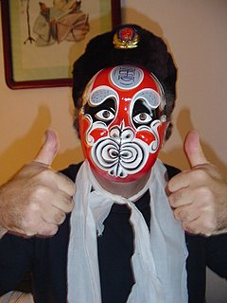
At night we went to the WuHou Temple area, and watched an amazing Cirque de Soleil-type performance by the local Chinese opera company…..magic mask-changings, dancing and singing, acrobatic and sleight-of-hand performances kept us mightily entertained! Robert at left was thrilled was the magic of mask-changing and couldn’t resist this look-alike face!!
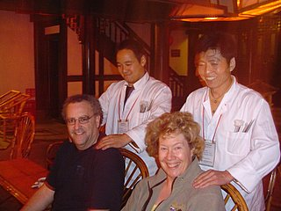
A massage during the performance certainly kept us relaxed and open to the fun of it all! These massages are available everywhere and are a great bargain! After the show we strolled the nearby shopping area, stopping for a beer and a very welcome pizza!
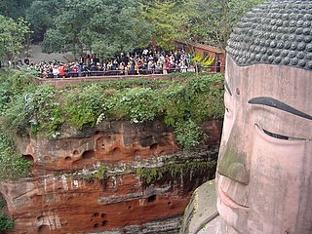
Sunday, we headed to Lushan, 2 hours south by bus. Our goal was to see the biggest carved-out-of-stone Buddha in the world, a UNESCO site. Take bus # 13 from the Lushan bus station, eventually ending up at the entrance. Paid our 80 yuan ($C 13.) and then had a great half-day exploring the gardens, bonsai exhibits, waterfalls and ponds full of goldfish, statues and memorials.
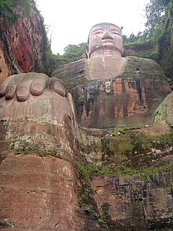
Finally you come out to the terrace which overlooks the head of Big Buddha…astounding!! 230 feet high, carved out of a solid cliff-face 1300 years ago and taking 90 years of hard labor. By the 1960’s it was almost completely overgrown with trees and moss but now is cleaned up and open to thousands of visitors. The Gonzo in us managed the steep staircase down to the feet of the Buddha and we gazed up in awe!

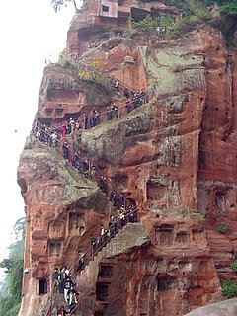
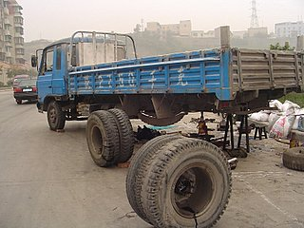
Our enjoyment at the great Chongqing-Chegdu-Leshan bus excursion came to an abrupt and grinding halt when we had to endure the “road to and from HELL” between Leshan and Chongqing. Oh, we thought we were clever slicing off 1 hour of bus travel by not backtracking our route! As soon as we left a beautiful Leshan bus terminal, we bobbed, weaved, slid, thumped, climbed mountainsides, grinded, dodged (cows, goats, potholes, people, chickens and ducks, earth mounds, gravel and stone droppings) and generally bottomed –out on the bus frame dozens of times on our springless, suspensionless bus on what would be generously called a trak, never a road! 3 hours of this and when we finally connected with a good road, found out we still had 163 kms. to Chongqing! Gad!!! Looking at the map, I still can’t figure out how to differentiate between good and bad roads! Saw a truck like this!!
To make matters worse, as we were gazing at the road in horror like a deer caught in the headlights of an oncoming truck , the man beside us started to chain-smoke….I descended into uncontrollable giggling for over an hour as Robert threw a handkerchief over his face, jammed his Cape Breton hat over his head, looking very much Lawrence of Arabia, and slumped into his seat…..Gad, gad and triple-GAD!!! Or make that GAG!
The weekend of Nov. 17 to 19 we were “supposed” to catch a plane to Xi’An but HEAVY Friday rush-hour traffic and absolute lack of taxis made us miss our final boarding time. Robert wheedled and connived to run onto the runway to jump on the departing plane to no avail…finally persuaded the official (25 years old and in charge of 70 agents) to give us a credit for next weekend. Ah well……
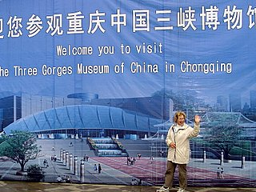
So this weekend we decided to explore Chongqing further…..headed for the newly-opened Three Gorges Museum, dedicated to amassing the artifacts which will soon be flooded-out in 2009. The 170 km. long 3 Gorges will be no more and a couple of million displaced people need new homes, hence the thousands of apartment buildings springing up in Chongqing.
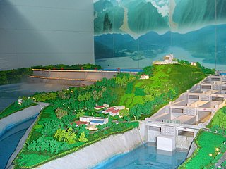
This new museum is beautifully organized and serves to display archeological jewels from the Yangtze River’s Chongqing to 3 Gorges area. The first floor is basically the dam construction and logistics. 18,000 kwh per day, making it the largest hydroelectric plant in the world by 2009. It is 2 kms. Across, 600 meters high and has 5 huge boat locks beside it, allowing much larger ships to cruise right up to Chongqing, opening up trade immensely.
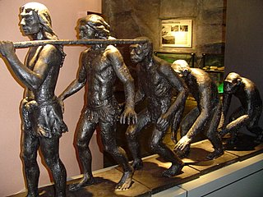
The second floor shows artifacts from the prehistoric (Paleolithic and Neolithic) man in this area,
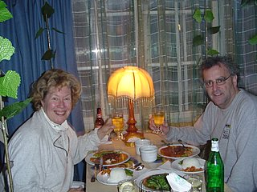
the third floor has a stunning display devoted to the Japanese invasion of China in 1937 and the fourth floor has more sculptures, bas reliefs and murals. Then had yet another great Sechwan meal! I went shopping with a Chinese teacher this past week and now have all the ingredients for “hotpot”…chilis, black sesame seeds, hot pickles, and “secret” ingredients….anyone visiting Robert and I will have their fill of HOT food!!! Lots of beer to wash it down, though, never fear!!
We went the Ancient Town of Chongqing, officially called Ci Qi Kou, an absolute warren of alleyways and quite the people place: food vendors, boutiques and artisans, entertainments and games. Three-generational families predominated, strolling the narrow streets and enjoying a warmish fall day. Robert and I did quite a bit of holiday shopping for the folks back home, discovering silk embroidery, wood carvings, stonewares and artwork that delighted us.
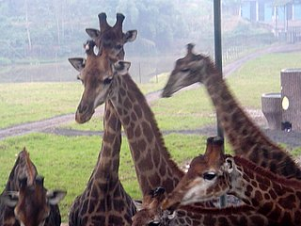
Back to reality on Monday, as we headed 100 kms. out of Chongqing to the zoo on a school field trip. This is a natural and open-spaced zoo which required a protective bus as we drove through herds of lions and tigers, giraffes,
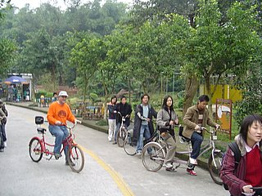
bears and wolf packs, kangaroos and emus. After, Robert encouraged the students to rent tandem bicycles (natch!)
for a tour through another area of the park, then we walked another area, seeing parrot/cockatoo shows, seal antics, a bear show, and finally got “close-up-and-personal with a white Bengal tiger…….
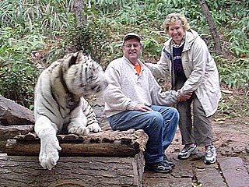
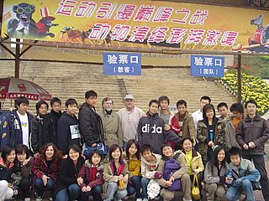
thought we were too close as the beast growled his unhappiness and I leaned away while pushing Robert gently towards the great animal!! A great day with a very special group of students!!

W eekend of Nov. 25-27 we flew north 600 kms. to Xi’An on Air Hainan, www.airhainan.com a mere 3 hours late leaving, due to a mysterious maintenance issue, which was announced every 3 minutes, to our annoyance. Anyways, upon arrival, we were being shepherded to a taxi stand when we asked the magic question….”How much?”. 180 yuan! ($C. 26) which was far too much for a 45 minute taxi ride (should cost about 80-100) so we jumped onto a bus for 25 yuan each which took us straight to the centre of Xi’An at the Bell Tower Square, at the Glory Hotel. Taxi took us quickly to our hostel from the Bell Tower. We would not recommend this hostel…. www.hostellinginternational.com grubby, plumbing pretty shoddy, noisy from a nearby bar on Saturday night. Ah well, hostels are usually pretty neat. One great thing about hostels is the people you meet…young, with-it, educated travelers…lots of e-mail trading at this one.
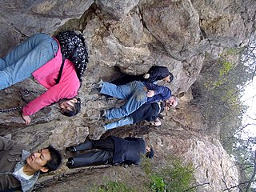
Saturday, headed out on tour with a group of 15, picked up right on time at our hostel. See my China reflections document about the perils of group tours…..Some of the stops were interesting….Chang Kaishek’s hiding place in the mountains when he fled with the fledgling Communist Party in 1937 was the great draw for many older Chinese. Robert, of course, scooted up the crevice, and up to the top of the mountain!

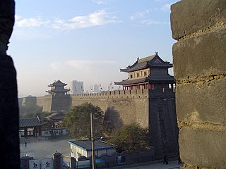

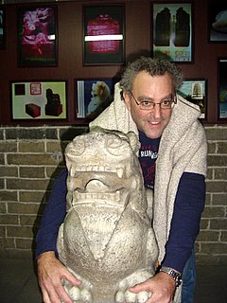
Xi’An itself has a great wall around it, 14 kms. total, and we stopped at the East gate for an hour to explore this ancient fortification, including rubbing a lion for good luck…Robert’s hands look real happy here! There was a jade shop and restaurant for lunch which I thought was sub-standard so more and more of us were refusing to go in….the tour guide had a bit of a rebellion on his hands.
Finally, we arrived at the Terra Cotta Warrior site, a UNESCO World Heritage, called the 8th wonder of the world. It was all this and more…..absolutely breathtaking! 2200 years ago the First Emperor of China, Qin, started his dynasty. Fearful of mortal death he proceeded to prepare for the after-life…. “hiring” slave labor, 720,000 prisoners, he commanded them to cast a complete army of terra cotta warriors to accompany him to the after-life.

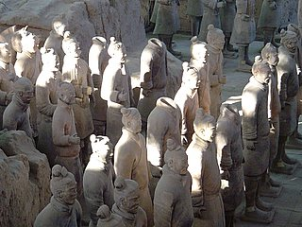
Many high-level artisans were engaged in this activity, thought to take well over a couple of decades in the 220’s BC
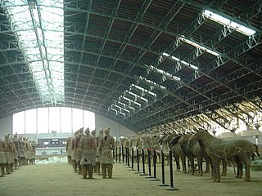
Since the accidental discovery by peasants digging an irrigation well in 1974 at the foot of a mountain range near Xi’An, there have been over 8000 terra cotta warriors unearthed, multitudes of horses, chariots, archers, and weapons have been excavated, cleaned, and put together. It really is astounding to see them standing guard for Emperor Qin, enclosed in air-conditioned museums that are the size of 3 football fields!
His mausoleum burial mound, 1.5 kms. away, is so huge that there is no technology in the world that can house it so it remains unexcavated!

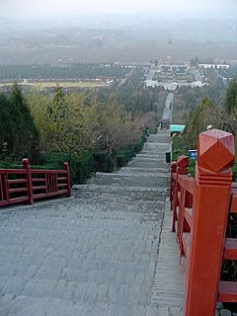
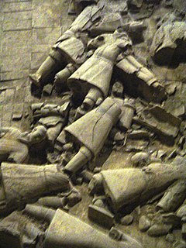
He was the first Emperor of China, introducing a money, calligraphy and law system which still endures and he started the building of the Great Wall, which now is over 7000 kms. long. Unfortunately he died at age 50 while inspecting the production of his terra cotta army, and within a year, Han of the Han dynasty bludgeoned and burned the terra cotta army ….archeologists of our modern day have had their hands full trying to piece together destruction. 30 years have passed since the discovery and they are no where near completing their excavation! It truly was an emotional time for Robert and I as we viewed the evidence of a powerful and creative Emperor! 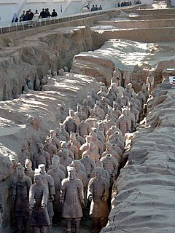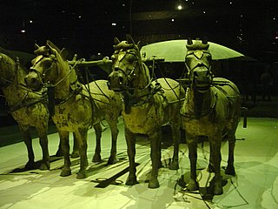

Long wonderful day so passed on the Tang Dynasty Dinner Theatre…. 029-8785-3295…booking number…….ah, well! Next trip!!

