CHINA- Nov. 27- Dec. 12, 2005

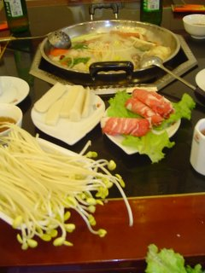
Ah yes, just another day in China…..great food with Chongqing expanding its culinary tastes from straight Sechwan (read: HOT POT) to so-called Shanghai, Beijing, Xi’An, Western (pizza with eel? with ostrich toppings? Or how about MickeyD’s with lambie burgers?) When I look back on my pictures, I see so many with FOOD….not just Robert’s fascination with “da food” but people gathered around yet another fabulous offering of amazing food, either at our home or in a restaurant! We saw so much good food “on the streets” at local vendors, avoided them as instructed by the Travel clinic but….BOY, looked and smelled “right some good”!!
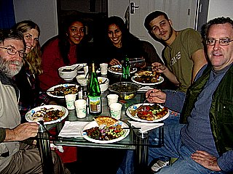
Last week, while Robert and the other teachers met with parents at school over the dreaded report card for their students, every night was a gathering with friends I have made here in China. One night was at Kristine’s, with 2 young people dropping by, Samantha and Camilla. The next night Camilla outdid herself preparing Italian pasta again for Kris and I, then the next night Kris and I made a ultra-western meal…..vegie soup and salad. Amazing how good Chinese food is, but even more amazing is how you revert back to the familiar Western food to give your system a rest, though (strangely?) there was rare heart-burn! Last night was a great potluck buffet western style at our place….at one point, 10 people of many nations were gathered ‘round, and everyone had brought a specialty….yum!
Particularly in this heartland of China, it is difficult to find western-type ingredients and spices, probably more accessible in Beijing or Shanghai. Big “problem” is the lack of fresh milk, cheese and a variety of meat….makes us big and strong (and full of cholesterol?) so the jury’s out on whether we need milk or not. Kristine is a master at sniffing out unsweetened bread, at figuring out how to microwave a fudge recipe, how to cook chocolate chip cookies and cake in a toaster oven. However she never did find a potato masher and I did have to bring sage and dill spices as well as a proper veggie peeler from Canada for her!
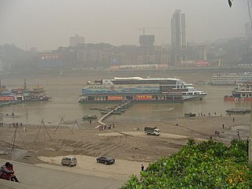
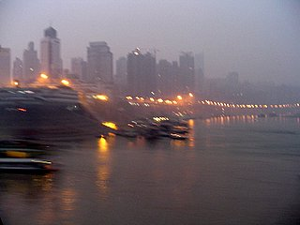
Back to reality for this travelogue……check out www.orientroyalcruise.com for the lowdown for a great cruise facility down the Yangtze River. Here we are, on an early December Saturday, exploring the ChaoTianamen Square at the port of Chongqing and we spot a 5-star cruise ship moored in the Yangtze River. “Let’s check it out” cries Robert! Next thing we knew we were being toured about the ship, saying YES, this is what we want to do! Hightailed it back to our apartment, packed fast while Robert made up lesson plans for the next week, and back to the cruise ship to sleep overnight. Yes, we left port at 7:00 AM sharp the next morning, with side-thrusters boiling the water, the East Queen ship making a complete 180 degree turn to face downstream…. seemed to me that we only cleared the other ships moored there by a few feet. Did the captain need help? Anyways, all cruise guests were up-top, clutching coffee for warmth, and the crew itself excited as this was their last cruise of the season, until it all starts up again in March.
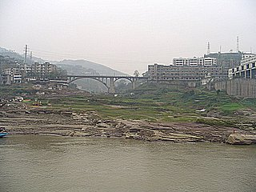
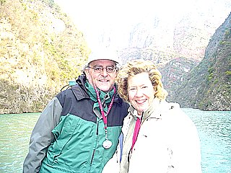
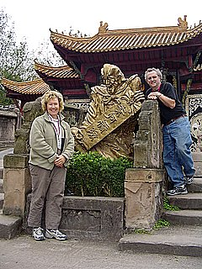
Our first day cruising downstream was past contrasts of farmland and industrial cities, with many shipyards. Very interesting to see the HUGE amount of silt piled up along the shorelines…..every spring flood the Yangtze (and the Yellow River, too, for that matter) scours the heart of China, bringing tons of silt downstream and eroding China seriously. There are many barges which scoop out the river bed but this could never replace what is lost from the farmlands. One sees farming efforts right on this fresh silt, right down to the river! Here today, gone tomorrow is an appropriate expression here! While we cruised, there were various workshops…..acupuncture, then silk embroidery, then brush painting. We enjoyed the acupuncture demonstration, then decided to have a one hour foot massage together….heavenly! Too bad we had to break for lunch at one point! NOT, says Robert!
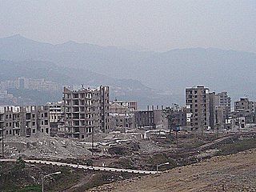
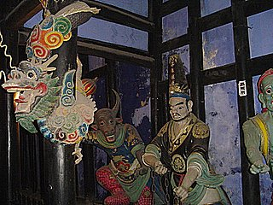
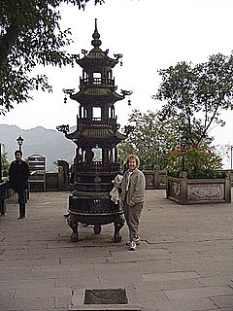
Mid-afternoon we docked at Fengdu, interesting for two reasons…..a whole section of the city will be underwater in 2 years due to the back-up of the Yangtze from the Great Dam (Three Gorges Project or TGP). As well, this is home to the famous Ghost City, a series of Confuscious, Taoist and Buddhist monasteries and temples which house the judges who examine the souls of the dead…..which way to heaven, hell or purgatory?? Fascinating legend, lore and superstition….our cruise group of 100 was in 3 groups and our tour guide was great to explain much of this history to us in English.

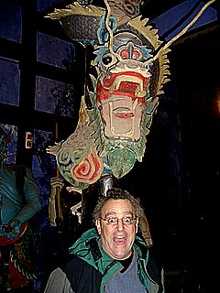
A tip here….if you travel China, it is always possible to hire an English tour guide….see photo at left!! This is a hot ticket for the educated and future-thinking Chinese, especially as the Beijing Olympics in 2008 are coming up fast.

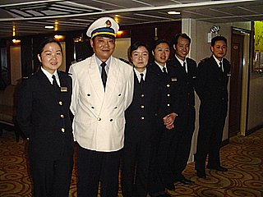
Back on our ship, we prepared for the Captain’s Reception where he greeted us all over a glass of wine and we settled into (YES!) another great meal. Strolled about the ship, then to bed for a wonderful lulling sleep while we rolled down the Yangtze…amazing!! We were SO excited as we anticipated the next day!
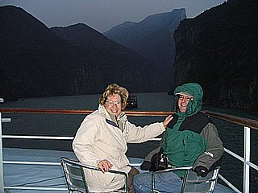
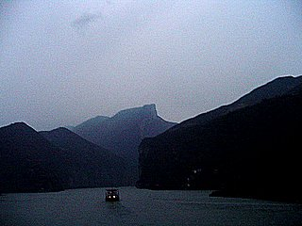
Yes, up again EARLY, clutching coffee for warmth, then into the first of the 3 great gorges….the Qutang. Spectacular cliffs rising straight out of the water, with little evidence of the famous dangerous shoals and sandbars that crunched boats in the past…the Yangtze is backed up to 150 meters (above sea level) from 120 meters and is scheduled to go up to 175 meters. Has completely covered the dangers BUT has sadly submerged caves, pictographs and artifacts from pre-history….many of these are in China’s museums but much history could not be saved. There is one interesting effort to preserve rock carvings of giant fish, inscribed by thousands of years of Chinese….they are constructing a water museum around the carvings, complete with water filter. The silt will not cover the carvings which tourists can now see from walkways above the water.
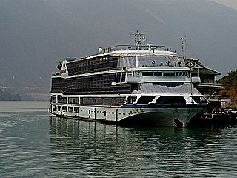
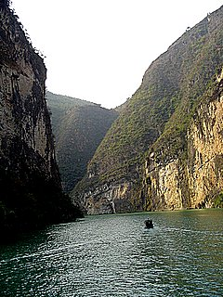
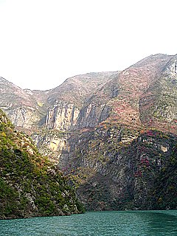
We whipped through the 8 km. long gorge in 10 minutes flat, craning our necks to try and see the top of these spectacular cliffs, remembering DuFu’s poem “Though you have ten thousand clever brushes, it is hard for you to paint the mountains on both sides of the Qutang”. Then we docked at Wushan, got on to a smaller pagoda-styled cruise boat and headed up the 3 Small Gorges on the Danling River. Narrower but just as soaring (you can see why the Gorges inspired artists and poets through the millenniums) we cruised 30 kms. up towards Dachang …… incredible to describe and the beauty was further enhanced by the bright red foliage of the Chinese maple tree. Named Dragon, Misty and Emerald Gorge in turn, we saw evidence of submerged walkways, plank roads and trackers paths…there was even a Buddhist temple moved high up on the cliffs. BUT, a highlight were the monkeys! Yes, 3 or 4 groups of them, close to the river or high up on the cliff, chattering and bouncing in the trees….were we all excited! Even the hanging coffins didn’t get the same reaction…..yes, many years ago, people’s coffins were tucked into the cracks of these cliffs for safe-keeping and can be spotted from below.
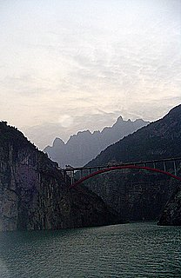
Back at the East Queen cruise ship, we headed back down the Yangtze and started through the Wu Gorge, 45 kms., with the highlight being the 10 Wu Peaks featuring the spectacular Goddess peak….. exciting legends surround these mountains! After, we passed by the mouth of the Shennongxi River, which, according to our tour guide, is even more astounding than the small 3 gorges of the Damling River.
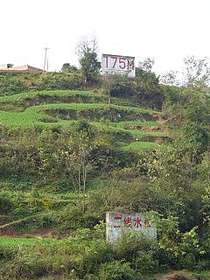
The superlatives keep flowing like the Yangtze! The Xiling Gorge came next, 66 kms. in total, breathtaking again, but sad for us too, as our tour guide recounted the countless artifacts and interest spots which are now submerged by the rising waters going up to 175 meters by 2009. Signs seen at left dot the Yangtze River, reminding people of their fate. A huge regret for the Chinese people must be the displacement of 1.3 million people, now forced to either the higher ground of their local areas or into the big, bustling (read congested and dirty) cities, especially Chongqing.
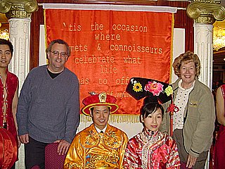
As we settled down to the Emperor’s Banquet dinner, we started our entrance into the lock system of the Three Gorges Project (TGP).

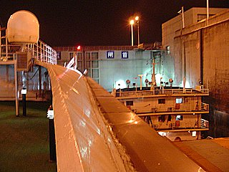
This in itself was worth the whole cruise…..how to begin the statistics for this enormous project?
It has been dreamed about for centuries, especially as a means to controlling the devastating floods of the Yangtze, which occur, on average, every 10 years. Millions of lives are lost in central and eastern China, especially in 1981 and 1998. In the 1940’s, some plans were made, then abandoned, and finally an American helped the Chinese pull all facts (dangers!) together during the 1970’s and 1980’s. Chairman Mao even wrote a poem about this dream to harness the Yangtze!
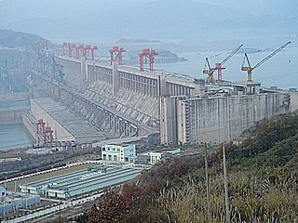
Facts:
- largest water conversancy project in the world, surpassing the one in Brazil by 30%, now 60 % completed.
-length is 2. 3 kms. long and a height of 185 meters (significant as the 175 signage along the Yangtze leaves only 10 meters between the top of the dam and the huge reservoir it has created) It is 115 meters wide at the bottom and 40 meters wide at the top.
-Dry season height of lake is 175 meters and flood season will be 155 meters with discharge vents through the middle area
-Ship locks are a double (upstream and downstream) 5 stage locks that total 113 meters high, with a trough length of 640 meters long and is 176 meters deep
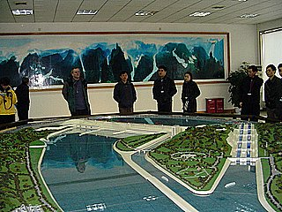
-26 powerhouse generators will be in place by 2009, with a yearly generating capacity of 18 billion KW and will power 10% of China’s needs. Brazil’s capacity is 12 billion KW, by comparison, and Canada’s 2 big projects total 1 billion KW. Coal consumption for powering plants will be enormously reduced, as will a huge decrease in waste water and CO2 emissions. Fact: there are 10,000 generating dams in China. China has ENORMOUS electricity needs and is trying to keep up to the GNP yearly growth of 10%!!
-Construction stats are impressive: millions of cubic yards of excavated earth and rock (100.2 billion cubic meters), concrete poured (2.7 billion cubic meters), Re-Bar (reinforcing rods) (35 billion tons), all making for world records in dam construction.
-Shipping sizes will rise from 1000-ton barges to 10,000- ton barges, making Chongqing a virtual seaport 1500 kms. inland from Shanghai!
-Displaced people…1.3 million and all received government compensation to re-locate, averaging US $10,000 each family.
-Problems- silt control (should be discharged every flood season)
-possible earthquakes from pressure on the earth’s crust from the weight of the water reservoir
-people problems…how unhappy are these displaced people??
-possible terrorist target
-loss of heritage and culture- a biggie as the flooding timeline was so short, the archeologists were not able to save much. The museum in Chongqing is impressive though, as it displays much of the excavated artifacts.

Truly impressive and one hopes that there will NEVER be any sort of collapse of this dam….
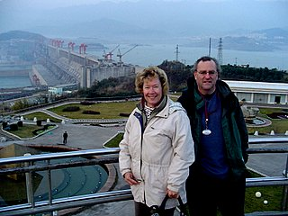
What more to say….we saw and were stunned even after all the anticipation before seeing this project. We were whisked to the Lichang airport, meeting a wonderful young man who is a great contact IF the canoe trip comes about. Rough, turbulent flight back to Chongqing (what is it with these mountain thermals in China? Flight from Xi’An was rough too!) and then, whoosh, taxi back to our apartment…..phew! WHAT a GREAT TRIP!!!!!

