JAPAN, Another Contrast but much less of a culture shock …..

Getting off the plane at Narita Airport northeast of Tokyo after a 3 hour flight from Beijing, one is immediately struck by the change from China……cleaner, for sure, but the people difference was marked. No one looked at me in amazement and then gave me a quick smile or nodded happily or started a curious crowd of people around me. When I puzzled over the airport maps and directions, no one came forward spontaneously BUT there were several instances of people happily helping me when asked specifically. One young Japanese lady actually carried my bag for me on the train forward 5 cars as I was on the wrong car and would end up going south of Tokyo when the train “split in two” half-way from the airport. Cost for the Narita Express train, necessary as it is a 74 minute (90 kms.) FAST moving train, is 3000 yen ($C30.) Taxis would be too expensive and a bus would take forever. Pretty ride through countryside and the first detached homes I’d seen since leaving Canada….China’s people live in grey, cubicle-style apartment buildings or in the back of “garages” which have their businesses in front.
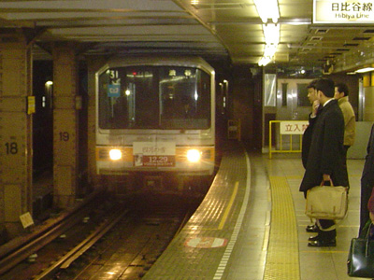
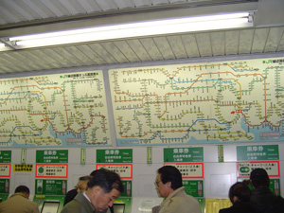
Got to Shinyuku train station (east of Tokyo centre), a small city in itself and waited for Brendan, bless his soul, who came to get me after teaching English to business people from 5:00 to 9:00. I was then introduced to the spaghetti which is the Tokyo subway system, pictured at left only 1/5 of the total lines!! …..the city itself runs many miles of subway and there are 4 other private companies which have additional lines. The trick to navigating this monstrous labyrinth is to look at a UNIVERSAL map which incorporates ALL lines, not just one company, find out where you are, check where you want to go and trust that you have the brains to follow the strand in the ball of yarn….YIKES! The Montreal, New York and London metro systems are NOTHING compared to this system! I spent the next 3 days with my hosts checking out subway maps to sightsee Tokyo and finally figured out how to negotiate it, with “just” a few slip-ups….even did it myself a few times!
A quick word on touring Japan in general……I was astonished that they do not cater to tourists the way China does. One of my hosts offered the perception that Japan doesn’t NEED westerners the way China does and that Japan is a more “closed” society….I couldn’t really concur with this conclusively and would need more time to check this perception. Another good excuse to come back!!
Anyways, my goal was to set up a tour to Mt Fuji and have an English-speaking guide. I had downloaded from the Internet such a tour when in Canada and had this in hand when I tried to set up a comparable tour. I went to hotels, travel agencies and bus stations with no luck. In these city establishments, people could barely speak English (compared to China which always had a few people with basic English and at least one who is quite fluent). I came up short-handed….all I can say is that you should book tours either before you arrive in Japan or while there from an Internet site, as tours ARE available when you check the websites. Soooo, I decided that instead of getting frustrated I would tour Tokyo completely for the 3 days and come back again…..great excuse for a return visit to check out the rest of Japan!
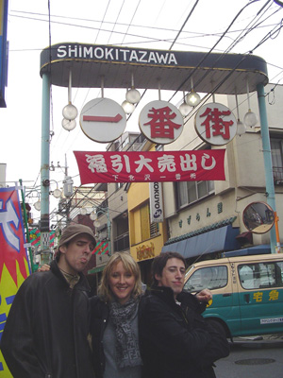
DAY 1- SHIMOKITAZAWA- This is where my hosts, Brendan and A.J, along with Jessica who was visiting for the month, have a great apartment…the area is a cross between Greenwich Village in NYC, Yorkdale in Toronto and Earl’s Court in London. It is quite bohemian and hippie-like, with lots of young people and wannabee-young-at-heart people…..very safe, open all night sort of place. We walked about and shopped, a major interest (or should I say obsession!) in Japan!

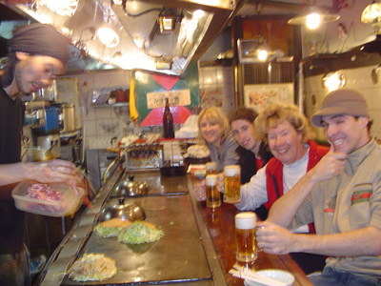
For lunch we found a wonderful Japanese restaurant with a huge grill….had the house specialities cooked up right in front of us, providing great entertainment! A helpful waitress read through the menu with us and then the chef got to work, smiling and gesturing as he put together the creations!
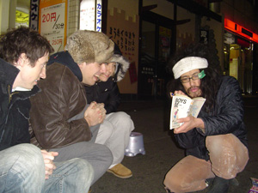
At night, the big entertainment was Manga Man, who had his audience sit down on little plastic chairs, someone would pick one of the many Anime comic books and Manga Man would mime his way through the comic, gestures and voice effects aplenty! Wonderful character in this bohemian village!
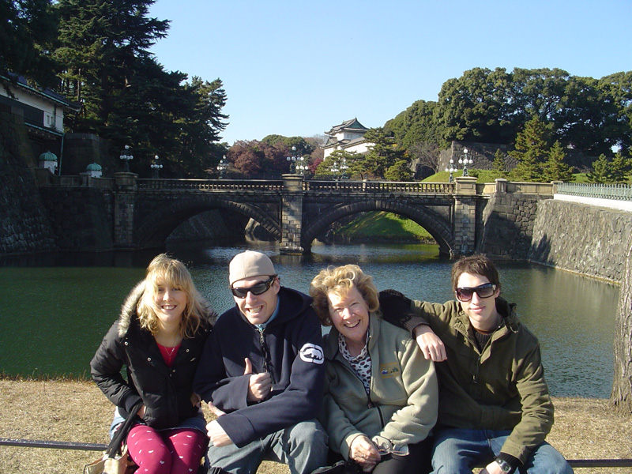
After, the guys had to go to work teaching English to local business people but first took Jess and I to the “Times Square” of Tokyo where we checked out a fabulous book store, a few shops and an HMV cyber-café. Nothing like checking e-mails and downloading pictures to feel right at home! Again, very little English anywhere so we had to resort to miming our way through the transactions with the cyber-café staff.
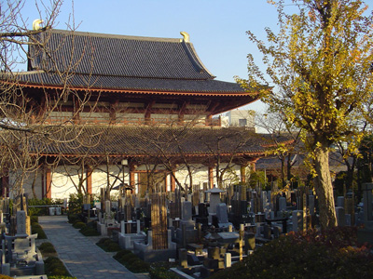
DAY 2 we took the subway to the Imperial Palace which has a HUGE garden that predominates central Tokyo…problem is it is only open one day a year (Dec. 23) so we had to admire it all from afar. After we walked south towards the Tokyo Tower, enjoying first Hibuya public gardens, then a traditional pagoda area with a modern cemetery near the pagoda complete with Buddha statues and prayer areas.

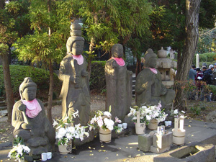

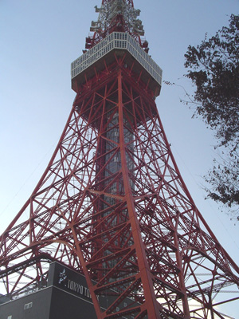
and finally the Tower itself……there was an elevator going up the innards of it but it is basically a cell site. Such a contrast again of old and new!! This is another major pre-occupation of the Japanese….their electronic gadgets, with everything from cell phones slash cameras that are “wafer-thin”, video-cameras slash digital cameras, ear-phone wires attached to their hidden cell phones…you name it, they have it in a MAJOR way. It seemed that everyone would be talking using a myriad of devices or pulling out their device to have a quick look at it!
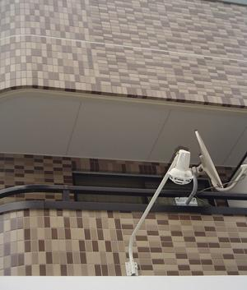
As we strolled Tokyo’s streets, it was pointed out to us the visible evidence of earth-quake proofing ……small indents (see photo) going straight across and up and down, which are rubber-based shock absorbers. Not visible are the giant shock absorbers underlying every building which is constructed (hopefully) according to a very strict code…apparently in an earthquake there are 2 distinct upward movements of a very sharp intensity, and then side-to-side swaying over a few minutes duration. All these shock absorbers are designed to minimize the impact……however, the older buildings such as the many pagodas are very vulnerable to the much-feared “Big One”, as a result of the many earth plates crunching against each other in this area of the north-west Pacific.
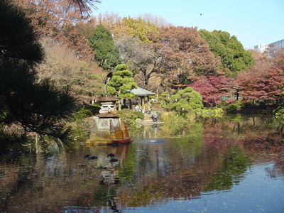
Everywhere you go in Tokyo, there are small prayer areas tucked into beautiful little gardens….we discovered a garden sanctuary at the top of a steep and long flight of stairs. There was a pond full of giant carp, grape vine arbours, pagodas as well as many prayer areas. Jessica had her “fortune” read by a visitor and A.J. was very good at interpreting for us all. Another area was a garden surrounded by 3 pagodas which held prayer areas. In contrast to the technological obsession, the Japanese will visit these sanctuaries during the day and spend quiet time there. They love their natural settings and apparently will tour outside the city to many of their national parks.
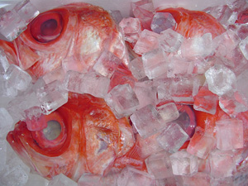
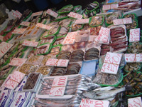
DAY 3 we headed for the big Ginza market…. an absolute warren of small streets that offer a multitude of quality goods and foods. I didn’t have enough time to visit the famous Tokyo fish market near the waterfront (open from 5-7 A.M. as the fish comes off the boats) but saw enough fish varieties in the Ginza market to goggle at! The squid and octopus were spectacular!

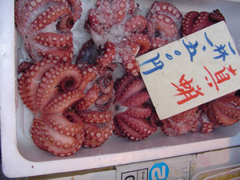
After the market we headed for the Sony building, checked out some robots which actually respond to you talking… “Give me a high five!” is one favourite with onlookers!
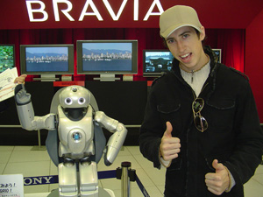

After the Sony Building, we checked out Hermes of Paris, a very upscale 4 story shop which had gorgeous clothes, accessories and, of all things, on the top floor, western riding saddles. Apparently the Japanese love the American West! Doesn’t compare to their obsession with Anne of Green Gables, though, that we have observed here in PEI!
This was a wonderful introduction to Japan and being with these energized young people who were so generous in touring me around was a great way to end my 2005 Asian adventure…..as I said, next time in Japan will be a week of checking out the rest of the country now that I’ve got Tokyo figured out….kind of!
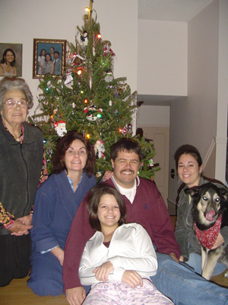
PS- Had a great stop-over in Toronto with my family and celebrated Christmas early…….will continue to celebrate Xmas when my globe-trotting sister and family come to visit Canada from New Zealand next month.
When I got back home, I figured that I was INSIDE an airplane for 73 hours in 2005, with all these trips to New Zealand and now Asia. Add to that approximately 40 hours of waiting to be checked through airport security and baggage handling, I can now say I am a pretty experienced traveller……enough for now!!!! If anyone would want web sites, phone numbers, contact information, I would be happy to supply them….
Next adventure, Europe for sure! A 6 hour plane ride to Italy will be a snap after the endurance tests of 14 hours in an airplane going from Toronto to Beijing!

Sue
December 2005
.

