Welcome to the 2003

Canadian National

Marathon Canoe

Championships/

Championnats Canadiens de Canot Long Parcours

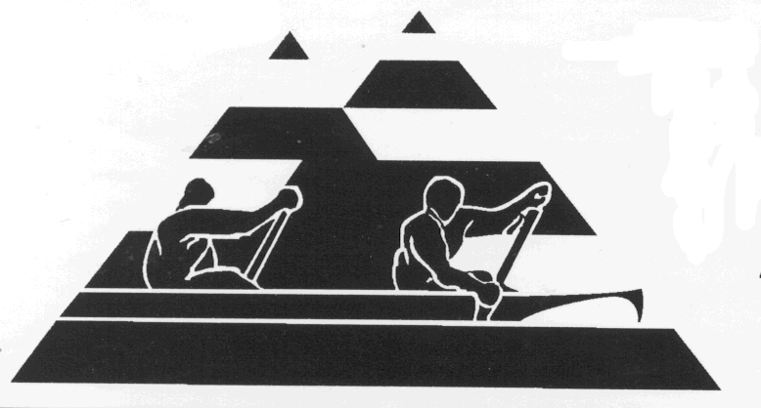

Kamloops, B.C. July 25, 26, 27
Hosted by the Kamloops Division of the Marathon Canoe Racing Association of B

Schedule of Events

Wednesday, July 23rd
Early registration, 4-6 p.m., Pioneer Park

Thursday, July 24th
Registration for all races, 4-6 p.m. Pioneer Park

Friday July 25th

7:30-8:15 Late Registration

8:15-8:45 Opening Ceremonies

9:00 Race Briefing / Explication du parcours

9:30 C2 Women Juvenile (15k, 1 portage)
Junior (17k, 1 portage)
Senior (29k, 2 portages)
Masters I (29k, 2 portages*)
Masters II (19k, 1 portage)

C2 Men Juvenile (15k, 1 portage)
Junior (17k, 1 portage)

9:40 C1 Men Senior (19k, 1 portage)
Masters I (19k, 1 portage)
Masters II (17k, 1 portage)
Masters III (17k, no portage)

12:00 C2 Bantam Open (~5k)

Canadian Canoe Association Marathon Rules apply.

*Portage requirement for Master classes may change.

Age Categories (as of January 1, 2003)

Peewee under 6
Bantam under 14
Juvenile under 17
Junior under 20
Masters I average age 40 and over
Masters II average age 50 and over
Masters III average age 60 and over

In C2 Youth Categories, the team will be placed in the category of the older member.

Have birth certificate and/or driver’s licence available in cases of dispute.

Saturday, July 26th

8:00 Late Registration

8:30 Race Briefing / Explication du parcours

9:00 C2 Men Senior (29k, 2 portages)
Masters I (29k, 2 portages)
Masters II (19k, 1 portage)
Masters III (19k, no portage)

9:10 C1 Women Junior (12k)
Juvenile (12k)
Senior (19k, 1 portage)
Masters I (19k, 1 portage)
Masters II (17k, 1 portage)

C1 Men Junior (12k
Juvenile (12k)

9:20 Stock C2 Women & Men - Open (15k, no portage)

3:00* C2 Adult/Peewee (~1.5k)
* tentative Adult/Bantam (~3k)
time Adult/Junior (15 yr gap) (~5.5k)

6:00 Banquet (details TBA)
Award Presentations (to-date)

Sunday, July 27th

8:00 Late Registration

8:30 Race Briefing / Explication du parcours)

9:00 C2 Mixed Senior (29k, 2 portages)
Masters I (29k, 2 portages)
Masters II (19k, 1 portage)
Masters III (19k, no portage)

9:10 C2 Mixed Junior (12k)
Juvenile (12k)
9:20 Stock Mixed Open (15k, no portage)

9:30* C1 Open Bantam (~1.5k)
*tentative time

Award Presentations after Sunday races (around noon)

The Race Course

The races will involve upstream and downstream paddling on the scenic North, South, and Thompson Rivers. There will be deep water, shallows, sand banks, buoy turns, and eddies. The level of difficulty and speed of the current will depend on water level. As these rivers are mountain fed the levels can fluctuate necessitating course modifications close to race day.

The race distance for each class on the attached Schedule of Events may change. The racecourse has been described as technical, challenging, fun, and ‘ideal’ for a Nationals venue.

The portage is in Pioneer Park. It is 150 metres long with easy approaches and a grass path.


In the stock class the canoe will be a max. length of 17'6" (not less than 15.2% @ amidships of the total length @ 4" waterline (31.92" W @ 17'6" L). Some 17’6” Clipper Trippers will be available for loan.

We encourage less experienced paddlers/novice racers to race in the stock class. Join in the fun!

The Venue

Kamloops has many amenities for hosting this premier marathon race: an excellent staging area at Pioneer Park and a technically challenging and scenic course on the confluence of the South Thompson and North Thompson Rivers, a good portaging area with superb viewing by spectators, and an almost guaranteed warm and sunny climate. There is a campsite across the river from the start and many motels and hotels close by.

Accommodations

Silver Sage Tent and Trailer Park – across from Pioneer Park adjacent to the South Thompson River. Showers available. Reservations: (250) 828-2077.

Thompson Hotel (250) 374-1999

Kamloops has a great variety of accommodations, some very convenient to the racecourse.

For more information contact:

Darryl Spencer, 250-376-6017 mspencer@ocis.net

Faye Hallett 250-963-8704 fhallett@mag-net.com

_________________________________

Entry Form Use a separate entry form per racer.

Name ____________________________ Age* ______
Address ______________________________________
City ____________________ Prov. _____ P.C.______
Telephone ________________ Sex: ___ Date________
Signature ___________________________
Guardian/parent signature (if under 18) _____________
* as of Jan. 1st, 2003

Emergency Contact during the Championship
Name _________________________________
Relationship _________ E-mail ___________________
Bus. Tel ______________ Home Tel ______________
Payment:

Make cheques payable to “MCRABC, Kamloops Division”. Entry form & cheque mailed to
___________________________________

Registration Fees:

$55.00 Entry Fee $30.00 under 18 yrs.
(The above includes t-shirt and banquet ticket)

$5.00 Adult Bantam, Adult/Peewee

$15.00 Extra t-shirt $15.00 extra banquet ticket

$15.00 Late Fee (if registration not rec’d before July 4^{th)}

Out-of-country participants add $10.00 CDN
(for insurance purposes)

Please register before July 4th

Entry Fee (See above)
Extra T-Shirts ($15.00 ea.)
Additional Meal Tickets ($15.00 ea)
Late Fee ($15.00 if rec’d after July 4th)
Out-of-Country Participant ($10.00)
TOTAL

Darryl Spencer 231 Monashee Place,
Kamloops, B.C V2C 6B5 Kamloops, BC V2C 6B5

